The process of completing the questionnaires
- Login: Students must log in to the Neptun student web interface.
- The To-Do list displays active, fillable questionnaires.
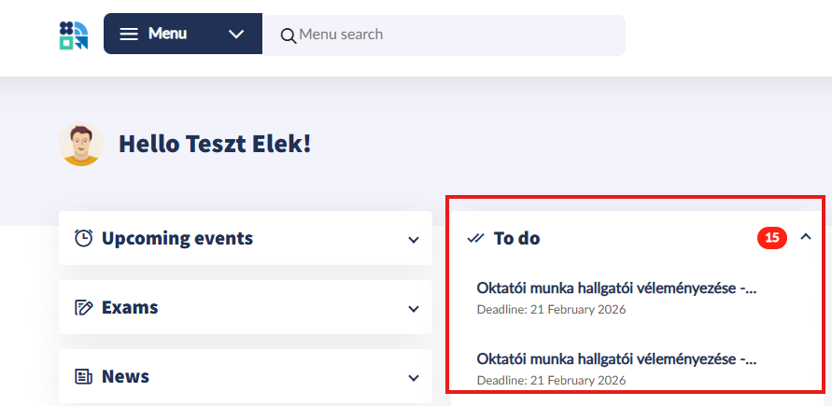
OR

- Selecting the menu: Move the cursor to the Administration menu item in the top menu bar, then select the Questionnaires option from the drop-down list.
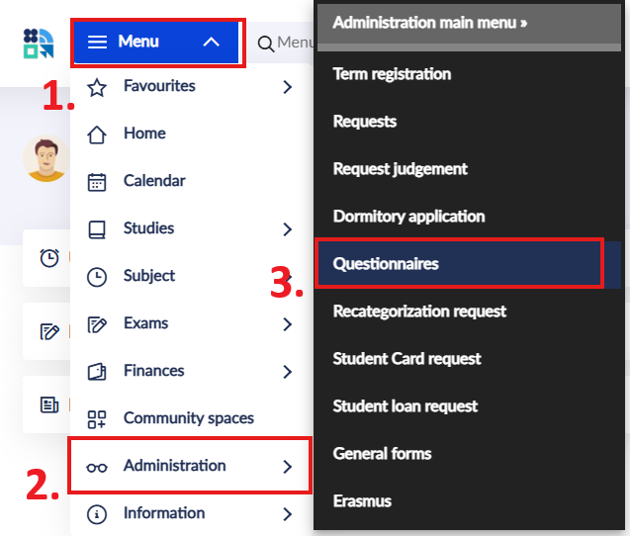
Searching for questionnaires:
The list that appears shows the current questionnaires that can be completed.
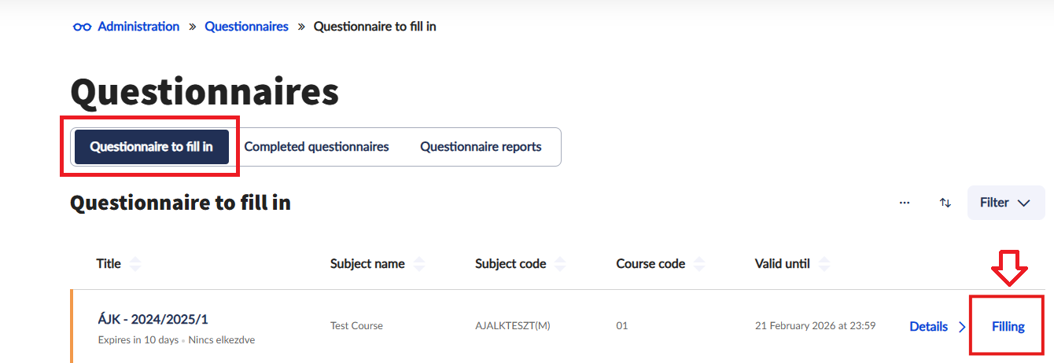

- Click the „Filling” button to start filling in the questionnaire.
- Answering: Now it's time to answer the questions.

