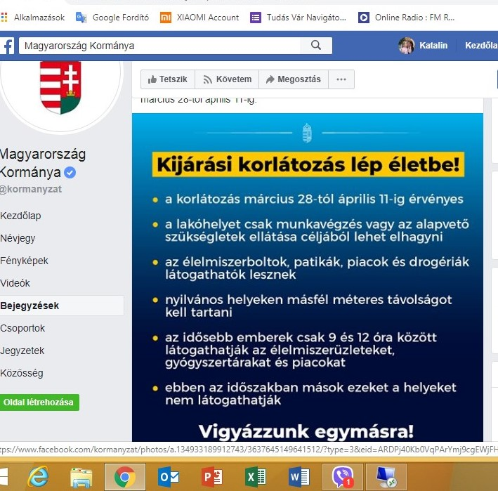

RESTRICTIONS – LOCKDOWN
- From 28 March to 11 April
- The place of residence may only be left for work or basic needs
- Groceries, pharmacies, markets and drugstores will stay open
- In public places you must keep a distance of 1,5 meter from each other
- Elderly people (above age of 65) are allowed to visit the groceries, pharmacies and market between 9 and 12 am
- Between 9 and 12 am other people (younger than 65) are not allowed to visit these places

